BEEE LAB EVALUATION

**AIM**: Design an automatic night lighting system (with 4 connected LED’s) such the system is only activated when the master control switch is pressed. a) Below 50% value of full brightness all LED’s constantly ON. b) Above 50% value of full brightness only first LED is ON.

**APPARATUS REQUIRED** : Arduino,4 LEDS , Photoresistor,Resistor,wires,Breadboard.

**THEORY**: When the surrounding brightnessis less than 50% of the full brightness, thenby the help of photoresistor all the LED’s glow constantly and when brightness is above 50% then onky the first LED glows.

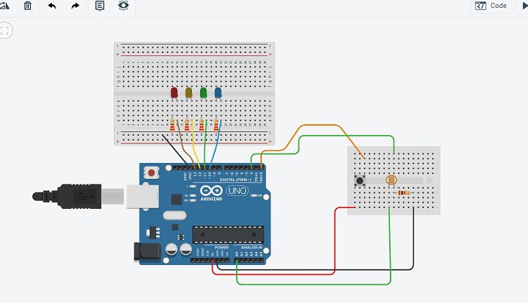

**PROGRAM** :

int LDR = 2;

int LDRValue = 0;

int light_sensitivity = 600;

int master_control;

int buttonPin = 0;

int buttonState;

void setup()

{

Serial.begin(9600);

pinMode(13, OUTPUT);

pinMode(12, OUTPUT);

pinMode(11, OUTPUT);

pinMode(10, OUTPUT);

}

void loop()

{

buttonState = digitalRead(buttonPin);

if(buttonState==HIGH)

{

LDRValue = analogRead(LDR);

Serial.println(LDRValue);

delay(500);

if (LDRValue < 300)

{ digitalWrite(13, HIGH);

digitalWrite(12, HIGH);

digitalWrite(11, HIGH);

digitalWrite(10, HIGH);

}

else

{

digitalWrite(13, HIGH);

digitalWrite(12, LOW);

digitalWrite(11, LOW);

digitalWrite(10, LOW);

}}

else

{

digitalWrite(13, LOW);

digitalWrite(12, LOW);

digitalWrite(11, LOW);

digitalWrite(10, LOW);

}

}

**LEARNING AND OBSERVATION** :-

1. When the brightness is below 50 % then, the 4 LEDs will glows automatically and when the brightness is above 50 %, then only first LED will glow .

2. This is very helpful to us and can help in saving energy at various places.

PRECAUTIONS:

1. Always ensure the positive terminal of the LEDs is connected to the output pin of the Arduino Uno.

2. Before uploading the code to the Arduino Uno.Check the port and board under the tools menu.

3. Always ensure that the connections are tightly. there should not be any loose connections between the port and the Arduino and Arduino and the breadboard.

4. Always check the LEDs is working or not before connecting to the circuit with the help of multimeter.

**RESULT**: Automatic night lighting system’s functioning was verified after uploading the program.